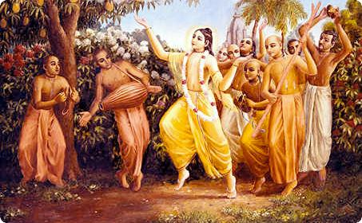

April 2011 Edition
www.soldiersofgodhead.yolasite.com
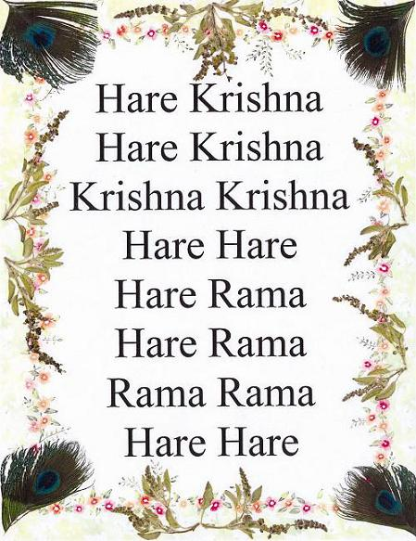
Chant Hare Krishna and be happy!
Contents
Sr.no Topics Page no.
- Success comes from Surrender. 5

- Cause of Stress in Life. 14

- Misconceptions about Lord
Krishna. 18

- False Incarnations and bogus
god men. 25

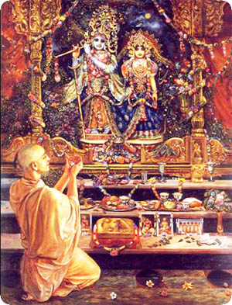
“Surrender all forms of religions and just surrender to Me. I shall free you from all sinful reactions, do not fear”, says Krishna. BG 18.66
- Success comes from Surrender.
According to the Padma Puran, there are 8.4 million species of life in the material world. Before achieving a human form, the living entity goes through all other species such as animals, insects, birds, fish, dog, hog etc. Then after millions and millions of births, he finally receives a human body. Thus, beyond a shed of doubt we can understand how valuable is the human birth. Man is a social animal. Hence, he has some animal tendencies like eating, sleeping, mating and defending. These tendencies are common to animals and humans and are known as animalistic tendencies.
Yet, there is a major difference between animals and humans and that is intelligence. Intelligence refers to proper application of mind and body. Since this human birth is so valuable, it must definitely have a purpose. So realization of this purpose is the first business of a human being and it is called Athato Brahma Jigyasa (inquiring about the self and the purpose of the human form of life). When one comes to the stage of Athato Brahma Jigyasa, then he actually begins his life as a human being. Otherwise simply engaging the mind and body in sense gratification is the animal way of life. So until one inquires about the purpose of this human life, he is an animal. The answer to this spiritual inquiry is stated in Shastras (the revealed Vedic scriptures) Aham Brahmasmi (I am not this material body. I am spirit soul.) This is stated in the Brahd -Aranyaka Upanishad. When one factually understands the distinction between spirit and matter, he realizes that he is not this temporary material body but is spirit soul. Krishna says in the Bhagavad Gita- Sarve Yonishu aham bija pradaha pitaha, “I am the seed giving father of all living entities.” Thus Krishna is the father of all living beings and we are His infinitesimal part and parcels. Krishna is Sat Chit Ananda Vigraha-the eternal form of truth, consciousness and transcendental bliss. A droplet of ocean water has the qualities of the entire ocean water. It too is salty and contains the same minerals as the ocean but there is a distinction in quantity. Since Lord Krishna is Sat Chit Ananda Vigraha so are we, since we are His children, His eternal parts and parcels. But the monistic theory of the droplet merging into the ocean and becoming one with it is not accepted by the scriptures or by the Supreme Lord. At no point can the part and parcel merge into and become one with the whole. Thus, the individual soul retains its individuality even after liberation. The Lord is a person and so are we. We are equal in quality to Krishna but there is a distinction in quantity. It is the business of the part and parcel to serve the whole. Just like all the parts of the body work to satisfy the whole body and not just individual parts. Similarly it is the duty of the living entities to serve the Supreme Lord Sri Krishna. This simultaneous oneness and difference is known as the Achintaya Behada Abheda philosophy (inconceivable simultaneous oneness and difference) and it was propagated by Lord Chaitanya Mahaprabhu who is the combined incarnation of Lord Krishna and Srimati Radharani in the form of a devotee of the Lord in the Kali Yuga. The Lord came in the form of a devotee to teach mankind the principles of devotional service and how one can go back home, back to Godhead simply by chanting His holy names in the form of the Hare Krishna Maha Mantra- Hare Krishna Hare Krishna Krishna Krishna Hare Hare/ Hare Rama Hare Rama Rama Rama Hare Hare. It is confirmed in the Brhan-naradiya Purana -
Harer Nama Harer Nama Harer Namaivam Kevalam Kalau Nastey Eva Nastey Eva Nastey Eva Gatir Anyatha-
Chanting the Holy names of the Supreme Lord Hari is the only way of deliverance in the age of Kali (the age of quarrel and hypocrisy) there is no other way, there is no other way, there is no other way.
It is further stated in the Kali Santarna Upanishad-
Hare Krishna Hare Krishna Krishna Krishna Hare Hare/ Hare Rama Hare Rama Rama Rama Hare Hare iti sodashakam namnam kali kalmasa nashnam nataha paratoropaya sarva vedeshu drishyate
Hare Krishna Hare Krishna Krishna Krishna Hare Hare/ Hare Rama Hare Rama Rama Rama Hare Hare, chanting these sixteen names of the Lord destroys all ill effects of the Kali Yuga. In all Vedic literatures no other method of achieving perfection is to be found.
Thus, we can see from the above Vedic injunctions, that the best way of achieving perfection in life and fulfilling the purpose of the human life is to chant the names of the Supreme Lord Sri Krishna. By chanting the Maha Mantra- Hare Krishna Hare Krishna Krishna Krishna Hare Hare/ Hare Rama Hare Rama Rama Rama Hare Hare one cleanses the mind of all material conditioning and contaminations and is able to engage the sense in the service of Krishna rather than engaging them in sense gratification. One develops pure love and devotion for the Supreme Lord simply by chanting the Maha Mantra. It is stated in Srimad Bhagavatam 5.18.12-
Yasasti bhaktir bhagvaty akinchana sarvair gunis tatra samasate surah Hrava abhaktasya kutoh mahad Guna
A pure devotee of the Lord has got all the good qualities. Proper use of mind, body and intelligence. But a non devotee has no good qualities. It is thus understood from these injunctions and can also be realized through personal experience, that when one becomes a pure devotee of Lord Krishna, he automatically develops all good qualities since he engages his senses, body, mind, intelligence and other resources in the service of Krishna. He need not strive to develop any good qualities like truthfulness, mannerisms, freedom from vices like intoxication, meat eating, illicit sex and gambling etc. Since he is a pure devotee of the Lord, he is chanting the Holy names of the Lord and thus he has all the good qualifications. However, the same cannot be said for a non devotee or an atheist or a demigod worshiper. Anyone who is not a pure devotee of Lord Sri Krishna, even though he maybe engaged in worship of some demigods like Shiva, Brahma, Ganpati and so-called incarnations like Saibaba etc, he is to be considered an atheist from the point of view of Vedic Injunctions. Lord Krishna says in Bhagavad Gita 7.20-
Kamis tais tair hratha janaha prapadyante anyadevataha
Those who are foolish and seek temporary material gain, surrender to the different demigods.
One must stop all forms of speculations and submissively read the authorized Vedic Scriptures like the Bhagavad Gita and Srimad Bhagavatam and realize his/her constitutional position in relation to the Supreme Lord Sri Krishna. Chanting the Maha Mantra and discharging loving devotional service to the Supreme Personality of Godhead Lord Sri Krishna is the purpose of this human life. Animals cannot worship or chant the names of the Lord. Only a human being can do this since he is blessed with intelligence. Thus, this human life is a loop hole for crossing over the ocean of repeated birth and death and to go back home, back to Godhead. Going to the abode of Lord Krishna-Goloka Vrindavan is the mission of human life. This mission can be achieved only by chanting the holy names of the Lord as it has been explained above. The Lord gives us some information about His abode in the Bhagavad Gita 15.6-
Na tat bhyasata suryoh na shashanka na pavakha yad gatva na nirvartante tat dhama paramam mama
“There is no sun, moon or electricity in my abode. There is no need for them since I’m personally present there. But the one who comes to my Supreme Abode once, does not fall again into the ocean of material miseries.”
Hence we should make it the sole mission of our lives to go back to Krishna and associate with Him in His Abode Goloka Vrindavan. There we can render personal service to the Lord and be free from the miseries of repeated birth, death, old age, disease, hunger, thirst, lust etc. How can we get to that supreme abode of the Lord? Krishna says in the Bhagavad Gita 18.66-
Sarva dharman paritajya maam ekam sharanam vraja aham tvam sarve papebheyo mokshasyami mah sucha
“Surrender all forms of religions and just surrender to my lotus feet. I shall free you from all sinful reactions, do not fear.”
Here Krishna clearly says that we must let go of our bodily conception of life. Leaving all forms of showcase religious customs and rituals we must simply surrender to Krishna. He assures us that we shall not incur sin of any kind by leaving other religious processes for His sake. The words mah sucha is significant since it indicates that we must not be fearful or hesitant in any way. The Lord personally assures us that He will personally take responsibility of all those who surrender at His lotus feet. Hence we must not hesitate and waste valuable time in speculations. Chanting Hare Krishna Maha Mantra and surrendering to the Lord we can overcome all our miseries and sufferings and achieve the ultimate perfection of Human Life. Becoming a pure devotee of Lord Krishna, surrendering at His lotus feet, chanting His names, glories, qualities, forms and pastimes, we can all achieve the supreme perfection of human form of life- pure love and devotion for the Supreme Lord Sri Krishna. Indeed surrendering to the Supreme Lord is the way of achieving success in human life. A society of devotees is peaceful and prosperous. However, that of atheists is violent, miserable, impious and full of unnecessary sufferings and disturbances as the world is experiencing these days in the form of terrorism, natural calamities, epidemics, global warming and much more. Hence becoming pure devotees of the Lord, we can achieve a peaceful existence in the material world and by chanting the Holy names of Krishna in the form of the Maha Mantra- Hare Krishna Hare Krishna Krishna Krishna Hare Hare/ Hare Rama Hare Rama Rama Rama Hare Hare constantly and incessantly, we can transfer ourselves to the abode of Krishna-Goloka Vrindavan at the hour of death and fulfill the purpose of the human form of life.
Hare Krishna!

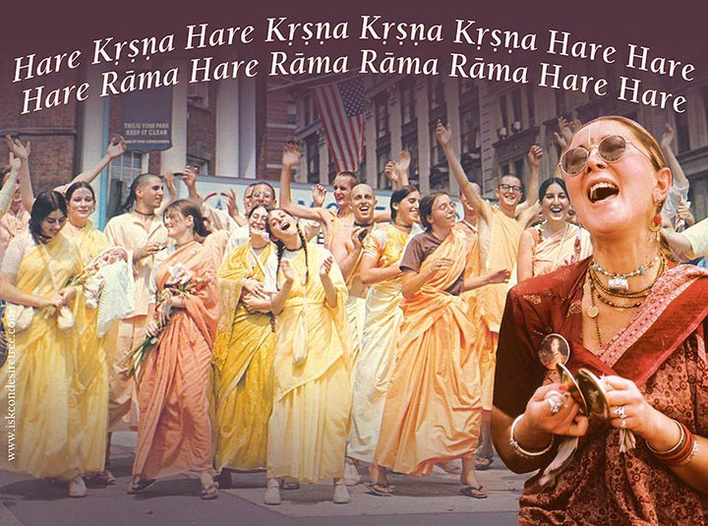
Srila Prabhupada took the Hare Krishna Maha Mantra to the west and commenced a worldwide spiritual revolution that continues to spread till date.

Forgetfulness of one’s relation with Krishna and the desire to enjoy material life is the cause of stress in life.

- Cause of Stress in Life.
As infinitesimal parts and parcels of Lord Krishna we are have the same qualities as Krishna, namely- eternity, consciousness, transcendental bliss, form etc. Krishna is the super soul and we are the individual souls. We are same in quality with Krishna but distinct in quantity. Thus, by nature we are ment to be eternally blissful, full of knowledge, and free from material miseries and contaminations. But, since we desire to enjoy the material energy ( ‘maya’ the inferior energy of Krishna) rather than associating with His spiritual energy, we fall into the ocean of material miseries. As soon as a living entity falls into the ocean of material existence he is influenced by the three modes of material energy- goodness, passion and ignorance. According to the mode of material nature that he associates with, he acquires different bodies, characteristics, intelligence, likes and dislikes etc. Thus, as long as a living entity stays in this material world, he must work according to the mode of material nature that he has acquired owing to his past activities. Under the influence of maya, the living entity identifies himself with the body that he acquires in every life. He thinks that he is the body. He thinks that the relations of the body are his relations and the possessions of the body are his possessions. He thinks that by increasing these bodily relations and possessions, he will become happy and enjoy a peaceful and prosperous life. In order to fulfill this desire, he works hard day and night to accumulate money which is the very means of sense enjoyment in the material world. And in this pursuit, he forgets that he is not the body, but is spirit soul, an eternal servant of Krishna. This forgetfulness of Krishna and the desire to enjoy bodily sense gratifications is called the bodily conception of life. The bodily conception of life is the result of the spirit soul’s association with maya and the reason for the spirit soul’s association with maya is his desire to enjoy sense gratification. This is the cause of all sufferings in life of not only human beings, but also animals, insects, birds, beasts etc.
As long as we think of ourselves as independent of Krishna, we can never be happy. We are by nature parts and parcels of Krishna. The parts and parcels can never be happy independently without serving and associating with the whole. The purpose of all the parts of the body is to satisfy the stomach. When the stomach is satisfied, all the parts are automatically satisfied. Thus, the way to cross over this ocean of material miseries is to engage in the loving devotional service of the Supreme Lord Sri Krishna. When we hear about Lord Krishna from pure devotees, when we see His pictures, when we hear His holy names being chanted, we are automatically attracted. The reason for this attraction is that Krishna Consciousness is dormant in the living entities. It is natural for us to serve Lord Krishna, but we are foolishly making attempts to enjoy independently.
We must associate with Krishna, chant His holy name in the form of the Maha Mantra- Hare Krishna Hare Krishna Krishna Krishna Hare Hare/Hare Rama Hare Rama Rama Rama Hare Hare. We must hear of His glories, qualities, names, forms, pastimes etc from His pure devotees, eat pure vegetarian food offered to Krishna and offer our obeisances to the Lord in His temple. Discharging devotional service in this way, we are sure to reduce the pangs and miseries of life by seeking shelter of the Supreme Personality of Godhead Lord Sri Krishna. By becoming devotees of the Lord, we let go of our desires to enjoy sense gratification which is called capala suka (insignificant and so-called pleasure) and relish the highest ecstasy- Love of God. When one advances in the discharge of loving devotional service to the Lord, he becomes free from the threefold miseries of material life and becomes a fit candidate to go back home, back to Godhead.

Hare Krishna!

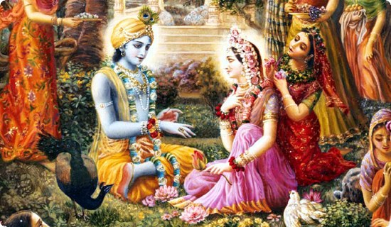
Foolish people don’t understand the transcendental relation between Lord Krishna and the gopis of Vrindavan and think of them in the material context.

- Misconceptions about Lord Krishna.
People with a poor fund of knowledge do not understand Lord Sri Krishna as He is. They have no scriptural knowledge or even if they do, they are the misinterpretations of the scriptural injunctions. In the Bhagavad Gita Krishna declares that He is the Supreme Personality of Godhead, yet atheists, monists, mayavadis (impersonalists), and others with little or no knowledge do not accept Krishna as He is. And this gives rise to various misconceptions about the Lord. Some of the prominent misconceptions about the Lord are:-
- Krishna is mythological figure and he did not and does not exist.
This is stated mostly by so called scientists and philosophers. They are puffed up with mundane knowledge and are very egoistical about their so called qualifications and achievements. They think they can prove everything and solve all problems through scientific advancement. This is called vijnana maya or the illusion that scientific progress shall solve all problems of human life. From practical experience we know to what extent this belief is true. As far as Krishna’s existence is concerned, we have conclusive evidence about Him, His names, forms, activities, and places of His pastimes very specifically mentioned throughout the Vedic scriptures. Even today one can visit the places of His pastimes in India and can find reference about His activities there in the Vedic scriptures like the Srimad Bhagavatam and Mahabharat.

- Krishna was a great man, but not the Supreme Personality of Godhead.
Krishna says in the Bhagavad Gita- Avajnanti mama mudaha manusim tanum asritah
“Fools do not chant my names and glories and when I come in the human form, they deride me as an ordinary human being.” (BG 4.8)
The entire Bhagavad Gita is centered around this one simple yet sublime conclusion- Krishna is the Supreme Personality of Godhead. And other scriptures like the Srimad Bhagavatam, Vishnu Puran, Brahma Samhita, Vedanta Sutra, the four Vedas, Katha Upanishad, Svetasvatra Upanishad, Gopal Tapani Upanishad, other Purans and Upanishads clearly declare Lord Krishna to be the Supreme Personality of Godhead. Krishna is not an ordinary human being. An ordinary human being cannot lift a mountain on a little finger and hold it there for seven days and seven nights. That is impossible for us. But Krishna had lifted the Govardhan Hill at the age of seven and held it for seven days and seven nights to protect the residents of Gokul from the wrath of Indra. This Hill is present in modern day Gokul, Mathura district, in the northern state of U.P in India.

- Krishna was immoral.
When people see a picture of Krishna and Radharani, or Krishna with the other gopis or hear or read about the rasa lila of the Lord, they conclude that Krishna was immoral and since god is having fun with other women, so should we! They take it as a sanction for immoral behavior. But only a fool could arrive at such a conclusion. Radharani is the expansion of Krishna Himself. She is His internal pleasure potency. Thus, Radha and Krishna are one. As far as the gopis are concerned, they are not ordinary cowheard women. They are the residents of Krishna’s abode Goloka Vrindavan and had descended on Earth to engage in pastimes with the Lord here. Neither Krishna nor Radharani or any other resident of Vrindavan was an ordinary human being. They were all pure devotees of Krishna. The Rasa lila of the Lord was a dance that symbolizes the reunion of the soul with the supersoul Sri Krishna. When a living entity attains liberation, he is immediately transferred to the eternal abode of Sri Krishna called Goloka Vrindavan. There he associates with the Lord and engages in loving exchanges with the Lord. This reunion is just like the reunion of two lovers who had been separated for a long long time. But unlike that of ordinary lovers, this is a transcendental union and there is only pure love and no element of lust. Thus, Krishna is not immoral and His loving exchanges with the gopis and with Radharani were pure and had no contamination of lust.
- There are many gods and they are all the same. Worship of any of them is the same as worship of Krishna.
This kind of thinking has been generated in society because of the poison spread by people like Ramkrishna “Paramhansa” and Swami Vivekananda. They think that Krishna is a mere incarnation of Lord Vishnu and that worshiping any god or following any religion will lead one to the same destination. This kind of thinking is faulty and is not supported by shastras. If it is true that worshiping demigods and Krishna is the same, then why does Krishna say in Bhagavad Gita 7.20- Kamais tai stair hrath janaha prapadyante anyadevataha. “Those fools who desire temporary material gains, worship the demigods.” Further Krishna says that the worshipers of the demigods go to the abodes of the demigods. But the devotees of Krishna go to Krishna. The difference is that one who goes to the demigods may fall back into the ocean of material miseries. And even if he dosen’t fall down, he will be annihilated during parlay or the annihilation of the material world at the end of Brahma’s one day. Krishna says in BG 15.6 that the one who comes to His abode Goloka Vrindavan once, does not fall down in the material world again. Further it is stated in BG 18.66 that everyone must give up all forms of religions and just surrender to the lotus feet of Sri Krishna. Krishna promises that He shall free us from all past sinful reactions and that we must not be hesitant or fearful. Thus, leaving all forms of religions and rituals, we must directly surrender to Krishna and seek the shelter of His lotus feet. This is the path of perfection.

- By meditation and spiritual practice anyone can become as good as Krishna.
There are many so called yoga societies in the world and many “yoga gurus” who claim that by practice of meditation or some other “spiritual practice” one can become as good as Krishna. Krishna is eternal. He has no birth, death, disease or old age. He appears on the material plane for giving protection and pleasure to His devotees and killing the demons. When His mission is complete and the principles of religion are reestablished, He returns to His eternal abode Goloka Vrindavan. Further, Krishna is complete in six opulences- Strength, Wealth, Knowledge, Beauty, Fame and Renunciation. He is simultaneously and fully complete in all these six opulences. Is any of the so called yogis having even one of these qualifications? On the strength of some mundane mystic power they claim to be god. But they can’t prevent their diseases, old age, death, the threefold miseries of life and the four principle defects. Thus no one but Krishna is God. Not even the demigods like Shiva and Brahma can claim to possess all of the above qualifications. What to speak of mundane yogis, gurus, swamis etc.

- Its not Krishna the person but the eternal, unborn nature within Him that is to be worshiped.
Krishna is the Supreme Personality of Godhead. He is the Supreme Absolute Truth, the last word in transcendence. According to the Srimad Bhagavatam, God is realized in three aspects- the impersonal Brahman, the localized Paramatma and Bhagavan, The Supreme Personality of Godhead. The impersonalists are on the platform of Brahman realization but that is not the perfect realization of God. One’s realization of God becomes perfect when he factually understands and accepts God to be a person. If we being Krishna’s parts and parcels have personality then how is it possible that Krishna lacks personality? Thus, the Advaita philosophy is self defeating. Krishna is a person like you and me but His qualities, potencies, energies and every other aspect is unlimited while that of ours is limited. We are equal to Krishna in quality but there is a huge distinction in quantity.

- When Krishna is merciful to me I shall surrender to Him.
This is usually the thinking of karmis (furitive workers). Pure devotional service means to worship Krishna without desiring any material benefits (even the basic necessities like food, clothing and shelter). One should have firm faith in Krishna that He shall fulfill all the needs of His devotees without being asked. Krishna is present as Paramatma (supersoul) in the heart of every living entity and therefore He knows the needs and desires of every living entity, especially His devotees. Thus, one should surrender to the lotus feet of Krishna without having any material desires in heart and must engage in the loving devotional service of the Lord. Instead of thinking of material gain or loss, one must focus on chanting the holy names of Krishna and make his life perfect. Krishna is an ocean of mercy, but only His pure devotees have tasted the nectar of His mercy. Thus, if one wants to experience Krishna’s mercy the only condition is that he becomes a pure devotee of the Lord.

Hare Krishna!

- False incarnations and bogus godmen.
There are many instances in world history when a conditioned soul has claimed himself to be God or God’s incarnation or sometimes even His representative and has spread some pseudo religious practices. The general innocent public having no means to identify a true incarnation or representative of God, have been fooled by such bogus god men. These so called incarnations and representatives of the Lord make false promises to their followers and the general public and sustain their faith through illusory tricks or mystic yoga practice or some other mundane method and making a show of religiosity or spirituality they get their personal ulterior motives fulfilled through their followers. The cause of such disasters is the lack of knowledge of the people in general about the qualifications of a true incarnation of God or His representative. Following are the qualifications of God, a true incarnation and representative of the Lord:-
Who is God?
According to Parashara muni who is the father of Srila Vyasadeva (the compiler of the Vedic Scriptures), God is one who has all six oppulences simultaneously in an unlimited quantity- Strength, Wealth, Knowledge, Fame, Beauty and Renunciation. We all have some of all the above oppulences. This is so because we are parts and parcels of Krishna. We are equal to Him in quality but not in quantity. Krishna has all the above oppulences simultaneously in an unlimited quantity. This is the difference between a conditioned soul and God (Krishna). Besides the above oppulences, Krishna is also transcendental to the three modes of material nature- goodness, passion and ignorance, the threefold miseries- Adhiyatmik (miseries of body and mind), Adhibauthik (miseries caused due to other living entities) and Adhidaivik (miseries caused due to the demigods and forces of nature). Krishna is also transcendental to the four principal defects- imperfect senses, the tendency of cheating, making mistakes and illusion. The above points clearly describe the distinction between an ordinary living entity and God (Krishna). Further, no mystic, yogi or baba or even a demigod must be accepted as God. God must be clearly glorified in the authorized Vedic Scriptures such as the Vedas, Upanishads and Purans.
An Incarnation of God
Following are the qualifications of a true incarnation of God:-
- He must be predicted in the authorized Vedic Scriptures such as the Vedas, Upanishads, Purans etc.
- There must be a precise account of His appearance, parents, teacher, activities/pastimes, and other details in the authorized Vedic Scriptures before His appearance on Earth.
- He must have all the holy symbols like conch, disc, mace, lotus flower, sun, moon etc at specific locations on His body.
- His hands must be long enough to touch His knees while standing erect.
- He must preach pure devotion to Lord Hari.
- He must punish the demons and protect the pious.
- He must perform acts which are impossible for human beings, mystic yogis etc.
- He must display all His oppulences.
- He must display His universal form.
Only when all the above conditions are fulfilled someone should be accepted as an incarnation of the Lord. Not otherwise.
A true Representative of God.
A true representative of the Lord is one who himself is a pure devotee of the Lord with unflinching faith. He must possess internal and external purity. He must abide by the four regulative principles of no meat eating, no intoxication, no illicit sex and no gambling. He must chant the holy names of Krishna and must spread the message of the Lord wherever He goes and must be compassionate upon the conditioned souls. He does not preach for a living. He lives for preaching. He has no material desires. His only desire is to serve the lotus feet of Krishna. Such a pure soul is rarely seen in the material world. Srila Prabhupada, Founder Acharya of ISKCON was a true representative of the Lord, who spread the holy name of Krishna all over the world and fulfilled the prediction of Lord Chaitanya Mahaprabhu, that His name would be chanted in every city, town and village of the world.
From the above, we get a clear understanding as to who is God, who is an incarnation of the Lord and who is a true representative of the Lord. The one who does not have all the qualifications of God, must not be accepted as God. The one who does not have all the qualifications of an incarnation, must not be accepted as an incarnation. And the one who has no qualifications of a pure devotee, must not be accepted as a representative of the Lord. By distinguishing between the authentic and the fake/bogus we can engage ourselves in the service of the Supreme Lord Sri Krishna and protect ourselves against imposters.

Hare Krishna!

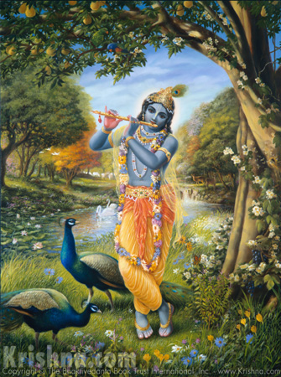
Dedicated at the Lotus feet of the Supreme Lord Sri Krishna.
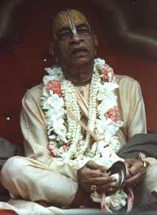
Dedicated to His Divine Grace A.C Bhaktivedanta Swami Prabhupada- Founder Acharya of the International Society for Krishna Consciousness.

Dedicated to Lord Sri Krishna and Srila Prabhupada.

Written, Edited, Published and Distributed by Rasabihari Dasa (Vinay Chakraborty)

For more information please visit www.soldiersofgodhead.yolasite.com

Do send us your queries, comments and suggestions at -vinay.chakraborty@yahoo.com

Hare Krishna!

